**CS 214 Database Technologies – SQL and NoSQL**

**PE06 - NoSQL Queries – find and projection**

Center for Information Assurance (CIAE) @City University of Seattle (CityU)

7/6/2020 Developed by Clark Ngo

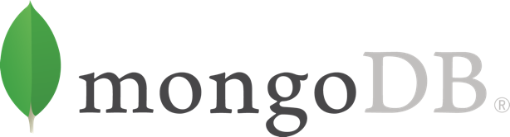

**Before You Start**

* If you have questions about the lab requirements, please ask a TA to clarify for you.
* If you are not sure what to do:
  1. Consult the resources listed below.
  2. If you cannot solve the problem after a few tries, ask a TA for help.

**Programing Exercise Tasks**

* Write NoSQL queries to complete the given tasks

Write a MongoDB query to display the fields restaurant_id, name, borough and cuisine for all the documents in the collection restaurant.

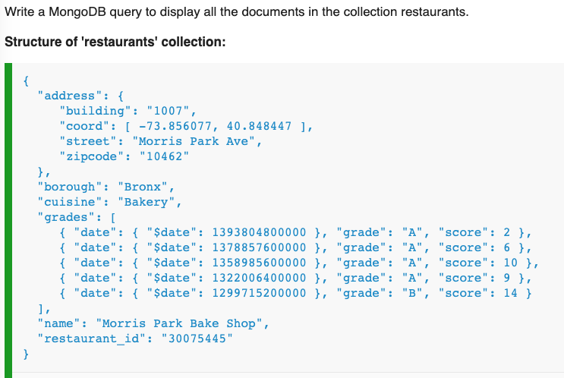

Research here: <https://docs.mongodb.com/manual/crud/>

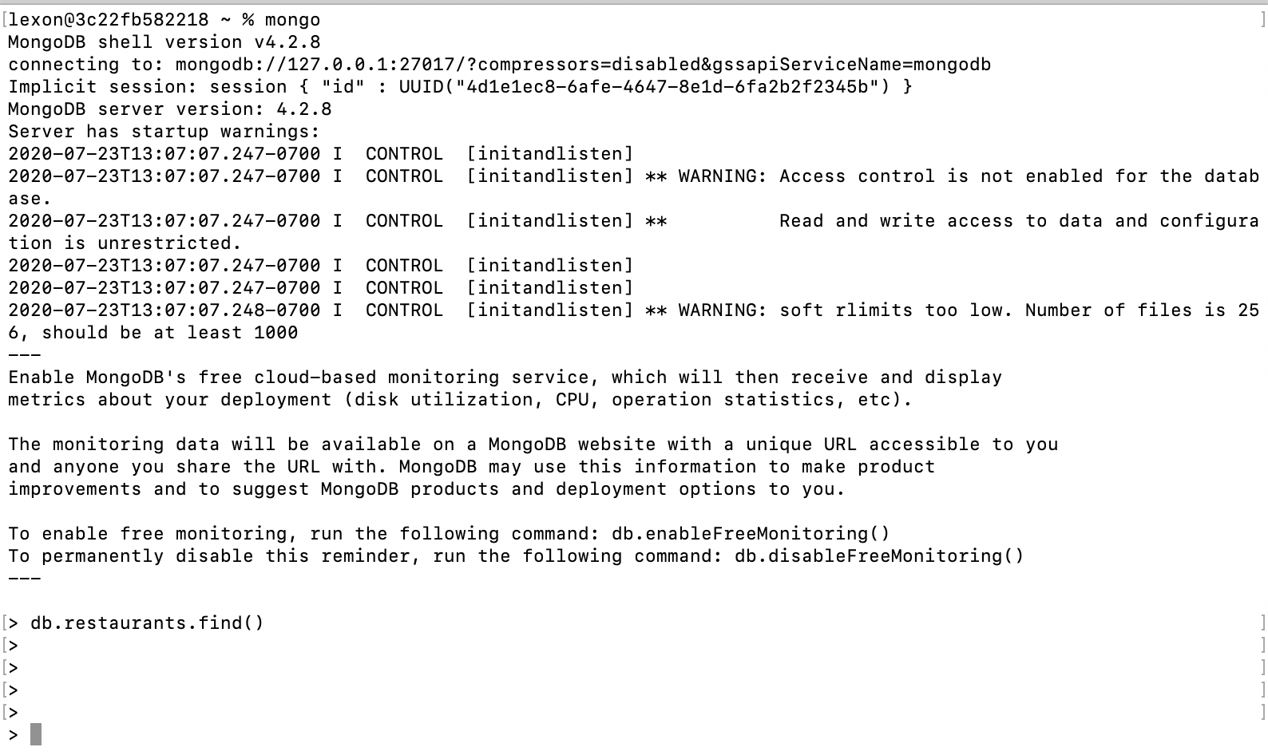

Write a MongoDB query to display the fields restaurant_id, name, borough and cuisine for all the documents in the collection restaurant.

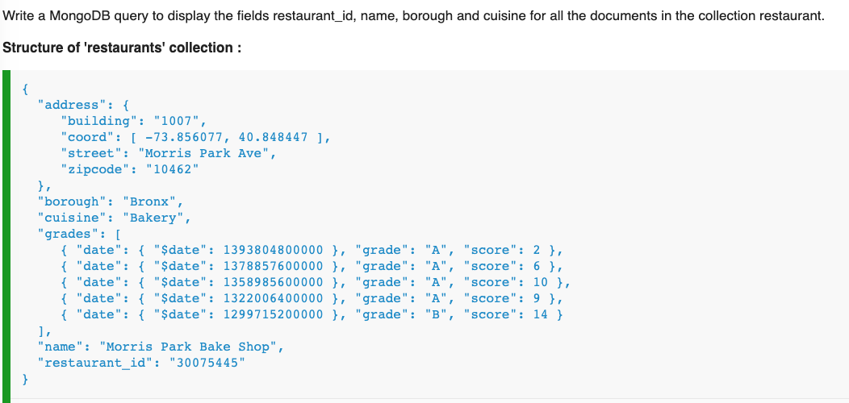

Research here: <https://docs.mongodb.com/manual/crud/>

